Lecture#13 SQFLite
Objectives
- SQFLite
- Add data(SQFLite)
- Delete data(SQFLite)
- Update(SQFLite)
- Get(SQFLite)

Sqflite:
Dependency: sqflite: any
Raw SQL queries:
// Get a location using getDatabasesPath
var databasesPath = await getDatabasesPath();
String path = join(databasesPath, 'demo.db');

// Delete the database
await deleteDatabase(path);

// open the database
Database = await openDatabase(path, version: 1,
onCreate: (Database db, int version) async {
// When creating the db, create the table
await db.execute(
'CREATE TABLE Test (id INTEGER PRIMARY KEY, name TEXT, value INTEGER, num REAL)');
});

// Insert some records in a transaction
await database.transaction((txn) async {
int id1 = await txn.rawInsert(
'INSERT INTO Test(name, value, num) VALUES("some name", 1234, 456.789)');
print('inserted1: $id1');
int id2 = await txn.rawInsert(
'INSERT INTO Test(name, value, num) VALUES(?, ?, ?)',
['another name', 12345678, 3.1416]);
print('inserted2: $id2');
});

// Update some record
int count = await database.rawUpdate(
'UPDATE Test SET name = ?, value = ? WHERE name = ?',
['updated name', '9876', 'some name']);
print('updated: $count');

// Get the records
List<Map> list = await database.rawQuery('SELECT * FROM Test');
List<Map> expectedList = [
{'name': 'updated name', 'id': 1, 'value': 9876, 'num': 456.789},
{'name': 'another name', 'id': 2, 'value': 12345678, 'num': 3.1416}
];
print(list);
print(expectedList);
assert(const DeepCollectionEquality().equals(list, expectedList));

// Count the records
count = Sqflite
.firstIntValue(await database.rawQuery('SELECT COUNT(*) FROM Test'));
assert(count == 2);

// Delete a record
count = await database
.rawDelete('DELETE FROM Test WHERE name = ?', ['another name']);
assert(count == 1);

// Close the database
await database.close();

DatabaseHandler Class
import 'package:sqf_lite_example/model/student.dart';
import 'package:sqflite/sqflite.dart';

class DataBaseHandler {
DataBaseHandler._privateConstructor();
static DataBaseHandler instance = DataBaseHandler._privateConstructor();
static Database? _database;

Future<Database> get database async {
_database ??= await initializeDatabase();
return _database!;
}

Future<Database> initializeDatabase() async {
String dbpath = await getDatabasesPath();
dbpath += "/studentdb.db";
Database db = await openDatabase(dbpath, version: 1, onCreate: _createdb);
return db;
}

Future<void> _createdb(Database db, int newVersion) async {
String query = '''create table Student
(
ID INTEGER PRIMARY KEY AUTOINCREMENT,
name TEXT,
age INTEGER,
contact TEXT,
image TEXT
)
''';

await db.execute(query);
}

Future<int> insert(Student std) async {
var db = await instance.database;
// String query =
// "insert into Student values ('${std.id}','${std.name}','${std.age}','${std.contact}')";
// int id = await db.rawInsert(query);
int id = await db.insert("Student", std.toMap());
return id;
}

Future<List<Student>> getAllStudents() async {
var db = await database;
List<Map<String, dynamic>> data = await db.query('Student');
List<Student> slist = [];
for (var element in data) {
slist.add(Student.fromMap(element));
}
return slist;
}

Future<int> delete(int id) async {
var db = await database;
int r = await db.delete('Student', where: "ID=?", whereArgs: [id]);
return r;
}

Future<int> update(Student student) async {
var db = await database;
int r = await db.update('Student', student.toMap(),
where: "ID=?", whereArgs: [student.id]);
return r;
}

Future<void> deleteDatabase(String path) async {
await databaseFactory.deleteDatabase(path);
}
}

Student model
import 'dart:convert';
import 'dart:io';

import 'package:flutter/services.dart';

class Student {
late int? id;
late String name;
late int? age;
late String contact;
late String? image;
Student(
{this.id,
required this.name,
required this.age,
required this.contact,
required this.image});
static Future<List<Student>> getStudents() {
List<Student> slist = [
Student(
id: 1, name: "Ali", age: 19, contact: "0312-5103078", image: null),
Student(
id: 2, name: "Ahamed", age: 20, contact: "0315-1503872", image: null),
Student(
id: 3, name: "Raza", age: 20, contact: "0333-5806078", image: null)
];

// return Future(()=>slist);
return Future.value(slist);
}

Student.fromMap(Map<String, dynamic> map) {
id = map["ID"];
name = map["name"];
age = map["age"];
contact = map["contact"];
image = map["image"];
}
static Future<String> encodeImage(File image) async {
var bytes = await image.readAsBytes();
var imgStr = base64Encode(bytes);
return imgStr;
}

Uint8List decodeImage() {
var decodedImage = base64Decode(image!);
return decodedImage;
}

Map<String, dynamic> toMap() {
return {
"ID": id,
"name": name,
"age": age,
"contact": contact,
"image": image
};
}
}

Lecture#15 Shared Preferences
Objectives
- SharedPreferences
- Login Status Example
- Save List(SharedPreferences)
- Get List(SharedPreferences)

Shared Preferences:
Dependency: shared_preferences: any
// Obtain shared preferences.
final prefs = await SharedPreferences.getInstance();

// Save an integer value to 'counter' key.
await prefs.setInt('counter', 10);
// Save an boolean value to 'repeat' key.
await prefs.setBool('repeat', true);
// Save an double value to 'decimal' key.
await prefs.setDouble('decimal', 1.5);
// Save an String value to 'action' key.
await prefs.setString('action', 'Start');
// Save an list of strings to 'items' key.
await prefs.setStringList('items', <String>['Earth', 'Moon', 'Sun']);

Example:
import 'package:flutter/material.dart';
import 'package:shared_preferences/shared_preferences.dart';

void main() => runApp(MyApp());

class MyApp extends StatelessWidget {
@override
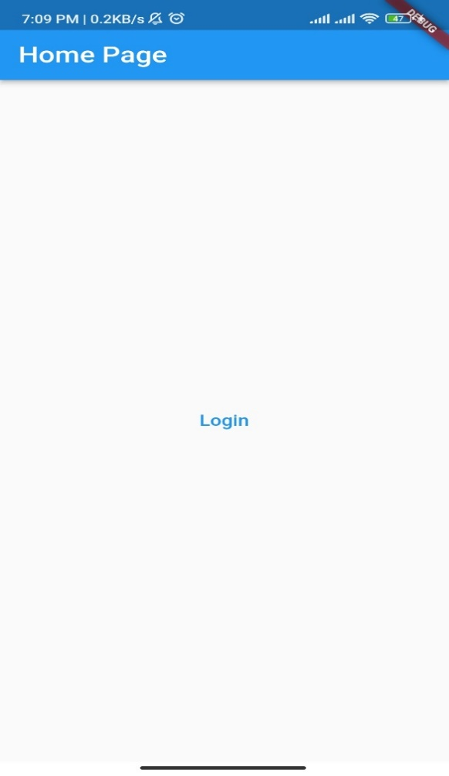
Widget build(BuildContext context) {
return MaterialApp(
title: 'Shared Preferences Example',
home: HomePage(),
);
}
}

class HomePage extends StatefulWidget {
@override
_HomePageState createState() => _HomePageState();
}

class _HomePageState extends State<HomePage> {
bool _isLoggedIn = false;

@override
void initState() {
super.initState();
_checkLoginStatus();
}

Future<void> _checkLoginStatus() async {
final prefs = await SharedPreferences.getInstance();
final isLoggedIn = prefs.getBool('isLoggedIn') ?? false;
setState(() {
_isLoggedIn = isLoggedIn;
});
}

Future<void> _toggleLoginStatus() async {
final prefs = await SharedPreferences.getInstance();
final newStatus = !_isLoggedIn;
await prefs.setBool('isLoggedIn', newStatus);
setState(() {
_isLoggedIn = newStatus;
});
}

@override
Widget build(BuildContext context) {
return Scaffold(
appBar: AppBar(
title: Text('Home Page'),
),
body: Center(
child: TextButton(
child: Text(_isLoggedIn ? 'Logout' : 'Login'),
onPressed: _toggleLoginStatus,
),
),
);
}
}

Example of how to save list of products in shared pref.
class Product {
int id;
String name;
double price;

Product({required this.id, required this.name, required this.price});
factory Product.fromJson(Map<String, dynamic> json) {
return Product(
id: json['id'],
name: json['name'],
price: json['price'],
);
}
}

When the user clicks the "Add to Cart" button for a product, you can create a new instance of the Product class with the product's ID, name, and price, and then add it to a list of products in the cart. For example:

void addToCart(int productId, String productName, double productPrice) {
Product newProduct = Product(id: productId, name: productName, price: productPrice);
cart.add(newProduct);
}

When the user clicks the "Cart" button, you can save the cart data to shared preferences. To do this, you can convert the list of products to a JSON string using the jsonEncode function, and then save the string to shared preferences using the SharedPreferences class. Here's an example:

void saveCart() async {
SharedPreferences prefs = await SharedPreferences.getInstance();
String cartJson = jsonEncode(cart);
await prefs.setString('cart', cartJson);
}

When the app starts up, you can load the cart data from shared preferences and convert it back to a list of Product objects. To do this, you can use the SharedPreferences class to get the cart JSON string, and then use the jsonDecode function to convert it to a list of maps. Finally, you can map each map to a Product object and add it to the cart list. Here's an example:

void loadCart() async {
SharedPreferences prefs = await SharedPreferences.getInstance();
String? cartJson = prefs.getString('cart');
if (cartJson != null) {
List<Map<String, dynamic>> cartMaps = jsonDecode(cartJson).cast<Map<String, dynamic>>();
cart = cartMaps.map<Product>((json) => Product.fromJson(json)).toList();
}
}

